**A-15.**

**Series RC Circuits**

**OBJECTIVES:**

After performing this experiment, you will be able to:

1. Compute the capacitive reactance of a capacitor from voltage measurements in a series RC circuit.

2. Draw the impedance and voltage phasor diagrams for a series RC circuit.

3. Explain how frequency affects the impedance and voltage phasors in a series RC circuit.

**READING:**

None

**MATERIALS NEEDED:**

One 6.8 kΩ resistor One 0.01 μF capacitor

Application Problem: Capacitor, value to be determined by student

**SUMMARY OF THEORY:**

When a sine wave at some frequency drives a circuit that contains only linear elements (resistors, capacitors, and inductors), the waveforms throughout the circuit are also sine waves at that same frequency. To show the relationship between the sinusoidal voltages and currents, we can represent ac waveforms as phasor quantities. A phasor is a complex number that is used to represent a sine wave’s amplitude and phase. A graphical representation of the phasors in a circuit is a useful tool for visualizing the amplitude and phase relationship of the various waveforms. The algebra of complex numbers can then be used to perform arithmetic operations on sine waves.

Figure 1 (a) shows an RC circuit with its impedance phasor diagram plotted in Figure 1 (b). The total impedance is 5 kΩ, producing a current of 1.0 mA. In any series circuit, the same current flows throughout the circuit. By multiplying each of the phasors in the impedance diagram by the current in the circuit, we arrive at the voltage phasor diagram illustrated in Figure 1 (c). It is convenient to use current as the reference for comparing voltage phasors because it is the same throughout. Notice the direction of the current phasor. The voltage and the current are in the same direction across the resistor because they are in phase, but the voltage across the capacitor lags the current by 90°. The generator voltage is the phasor sum of the voltage across the resistor and the voltage across the capacitor.

The phasor diagram illustrated by Figure 1 is correct at only one frequency. This is because the reactance of a capacitor is frequency dependent as given by the equation

$$X_{C}=\frac{1}{2πfC}$$

As the frequency is raised, the reactance (XC) of the capacitor decreases. This changes the phase angle and voltages across the components. These changes will be investigated in this experiment.

|  |  |
| --- | --- |
| D:\800_university\002_INHA_UNIVERSITY\조교_수업\정보통신기초설계\정보통신기초설계_강의노트_2016_이후\4차_챕터추가_A10-A15_추가수정\media\image2.jpeg | D:\800_university\002_INHA_UNIVERSITY\조교_수업\정보통신기초설계\정보통신기초설계_강의노트_2016_이후\4차_챕터추가_A10-A15_추가수정\media\image3.jpeg |
| (a) Circuit | (b) Impedance phasors |
| D:\800_university\002_INHA_UNIVERSITY\조교_수업\정보통신기초설계\정보통신기초설계_강의노트_2016_이후\4차_챕터추가_A10-A15_추가수정\media\image4.jpeg | |
| (c) Voltage phasors | |

Figure 1

**PROCEDURE:**

1. Measure the actual capacitance of a 0.01 μF capacitor and a 6.8 kΩ resistor. Enter the measured values in Table 1. If you cannot measure the capacitor, use the listed value.

2. Connect the series RC circuit shown in Figure 2. Set the function generator for a 500 Hz sine wave at 3.0 Vpp. The voltage should be measured with the circuit connected. Set the voltage with the oscilloscope and check both the voltage and the frequency with the scope. Record all voltages and currents throughout this experiment as peak-to-peak values.

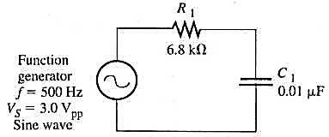

Figure 2

3. Using the two-channel-difference technique (CH1 - CH2), measure the peak-to-peak voltage across the resistor (VR). Then measure the peak-to-peak voltage across the capacitor (VC). Record the voltage readings on the first line of Table 2.

4. Compute the peak-to-peak current in the circuit by applying Ohm’s law to the measured value of the resistor:

$$I=\frac{V_{R}}{R}$$

Since the current is the same throughout a series circuit, this is a simple method for finding the current in both the resistor and the capacitor. Enter the computed current in Table 2.

5. Compute the capacitive reactance, XC, by applying Ohm’s law to the capacitor. The reactance is found by dividing the voltage across the capacitor (step 3) by the current in the circuit (step 4). Enter the capacitive reactance in Table 2.

6. Compute the total impedance of the circuit by applying Ohm’s law to the entire circuit. Use the generator voltage set in step 2 and the current determined in step 4. Enter the computed impedance in Table 2.

7. Change the frequency of the generator to 1000 Hz. Check the generator voltage and reset it to 3.0 Vpp if necessary. Repeat steps 3 through 6, entering the data in Table 2. Continue in this manner for each frequency listed in Table 2.

8. The data in Table 2 indicate how the voltage across the resistor and the voltage across the capacitor vary with frequency. Plot both the voltage across the capacitor and the voltage across the resistor as a function of frequency on Plot 1 of your report.

9. From the data in Table 2 and the measured value of R1 draw the impedance phasors for the circuit at a frequency of 2000 Hz on Plot 2(a) and the voltage phasors at the same frequency on Plot 2(b).

|  |  |
| --- | --- |
| **Report for**  **Experiment A-15** | **Name**  **Date**  **Class** |

**ABSTRACT:**

**DATA:**

**Table 1**

|  |  |  |
| --- | --- | --- |
| Component | Listed  Value | Measured  Value |
| C1 | 0.01 μF |  |
| R1 | 6.8 kΩ |  |

**Table 2**

|  |  |  |  |  |  |
| --- | --- | --- | --- | --- | --- |
| Frequency | VR | VC | I | XC | Z |
| 500 Hz |  |  |  |  |  |
| 1000 Hz |  |  |  |  |  |
| 1500 Hz |  |  |  |  |  |
| 2000 Hz |  |  |  |  |  |
| 4000 Hz |  |  |  |  |  |
| 8000 Hz |  |  |  |  |  |

***Step 8*** (Graph of Voltage Versus Frequency):

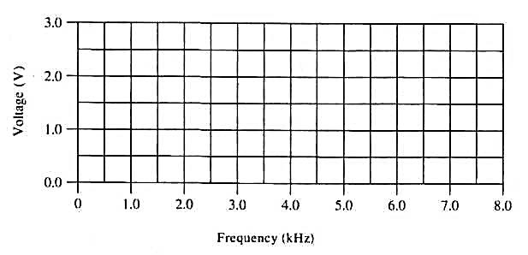

Plot 1

***Step 9*** (Impedance and Voltage Phasors for 2000 Hz):

|  |  |
| --- | --- |
| D:\800_university\002_INHA_UNIVERSITY\조교_수업\정보통신기초설계\정보통신기초설계_강의노트_2016_이후\4차_챕터추가_A10-A15_추가수정\media\image9.jpeg | D:\800_university\002_INHA_UNIVERSITY\조교_수업\정보통신기초설계\정보통신기초설계_강의노트_2016_이후\4차_챕터추가_A10-A15_추가수정\media\image10.jpeg |
| (a) | (b) |
| **Plot 2** | |

**RESULTS AND CONCLUSION:**

**EVALUATION AND REVIEW QUESTIONS:**

1. The Pythagorean theorem can be applied to the phasors drawn in Plots 25-2. Show that the data in both plots satisfy the equations

2. Assume you needed to pass high frequencies through an RC filter but block low frequencies. From the data in Plot 1, should you connect the output across the capacitor or across the resistor? Explain your answer.

3. (a) What happens to the total impedance of a series RC circuit as the frequency is increased?

(b) Explain why the phase angle between the generator voltage and the resistor voltage decreases as the frequency is increased.

4. A student accidentally used a capacitor that was ten times larger than required in the experiment. Predict what happens to the frequency response shown in Plot 1 with the larger capacitor.

5. Assume no current flowed in the series RC circuit because of an open circuit. How could you quickly determine if the resistor or the capacitor were open?

6. From Plot 1, predict the frequency at which the phase shift is 45° between the source voltage and current.